Edge Intelligence Lab-5- 10.01.2026
D. Sai Mohith
25MML0032

Phase 2: Impulse Design, Feature Extraction, and Model Training Steps
- Select Create Impulse
  - Click Create Impulse after navigating to the Impulse Design area.
  - Choose Image under Add Processing Block.
  - Select Transfer Learning (Images) under Add Learning Block.
  - To increase accuracy and shorten training times, transfer learning makes use of a pre-trained model.
- Choose Save Impulse
- Click Save Impulse once the blocks have been chosen. This sets up the data flow and gets the project ready for feature extraction.
- Create Features from Pictures
- Click on Generate Features after selecting the Generate Features tab under Impulse Design's Image option.
- In this stage, unprocessed photos are transformed into characteristics that the machine learning model can comprehend.
- Develop the Model and Obtain Precision
- To save and train, click. Using the features that were collected, Edge Impulse will train the model and present performance metrics, loss graphs, and training and validation accuracy.
Screenshots:
Transfer Learning
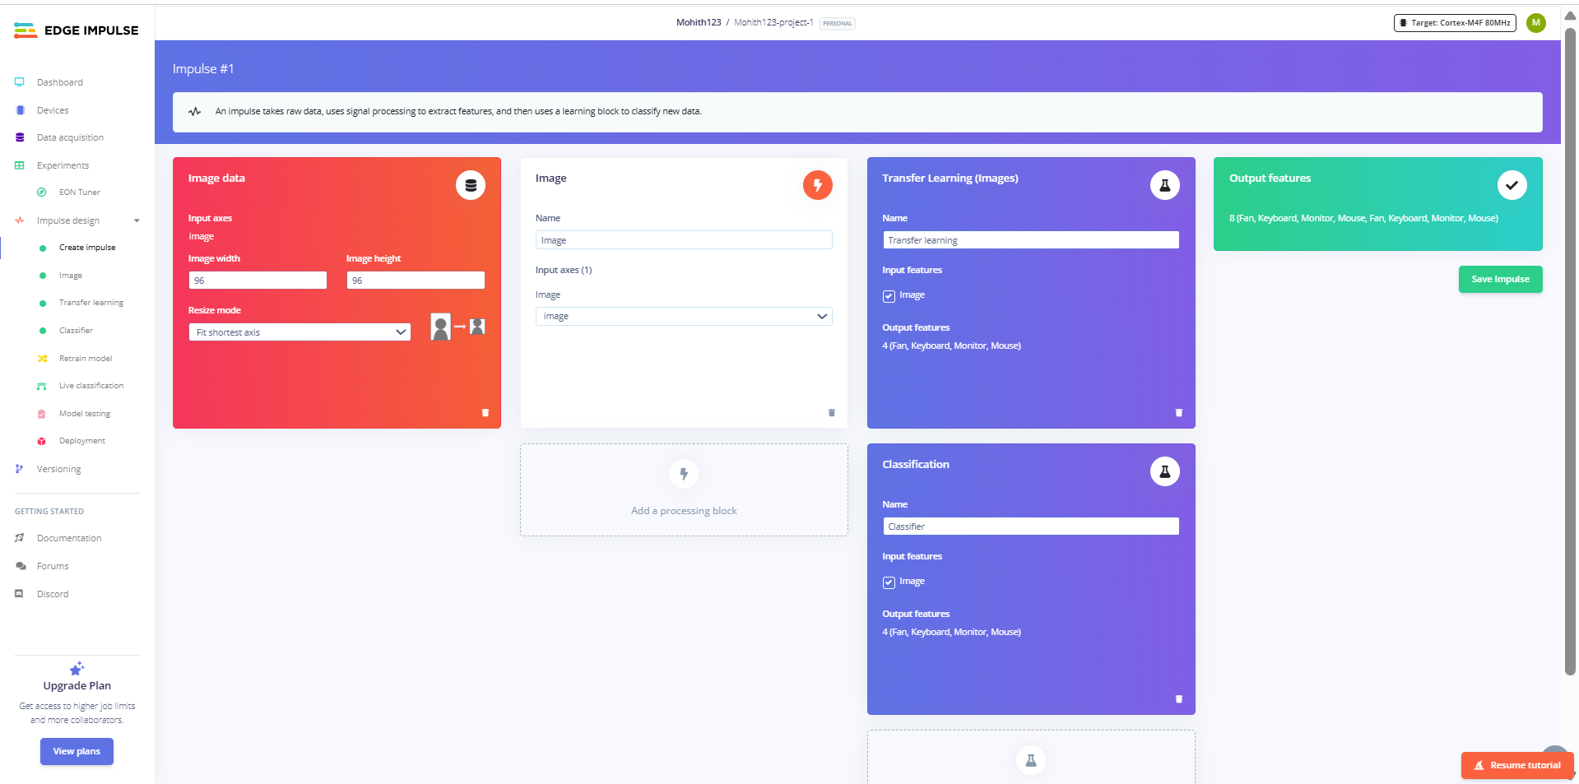
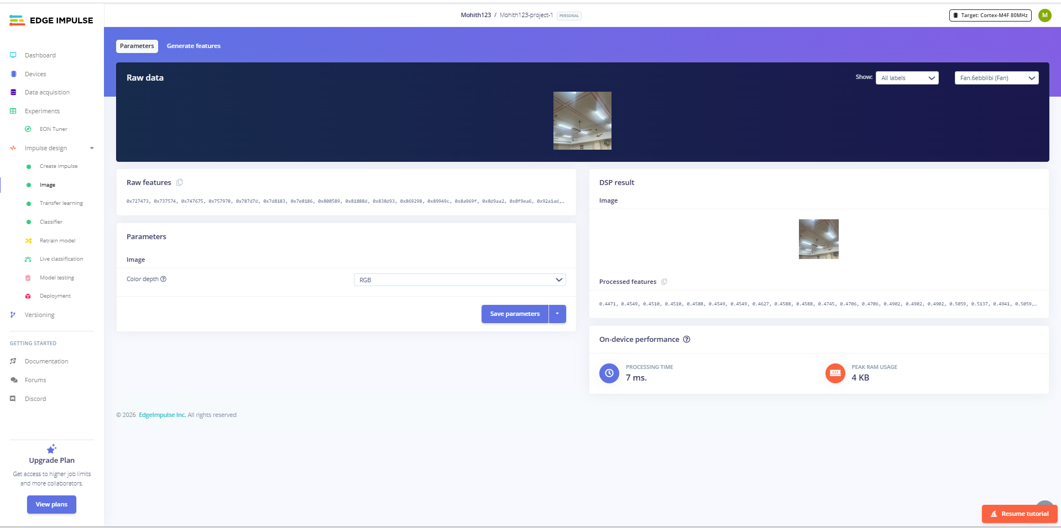

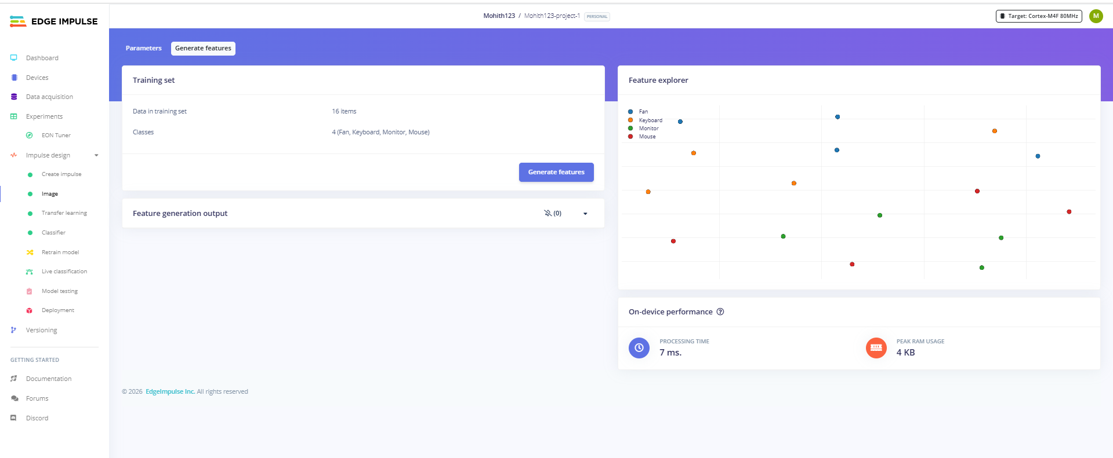

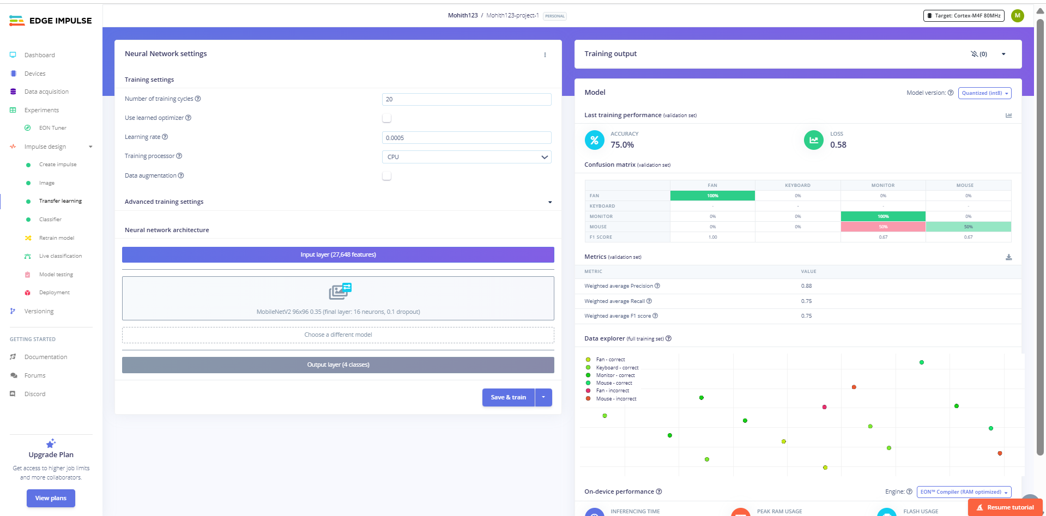
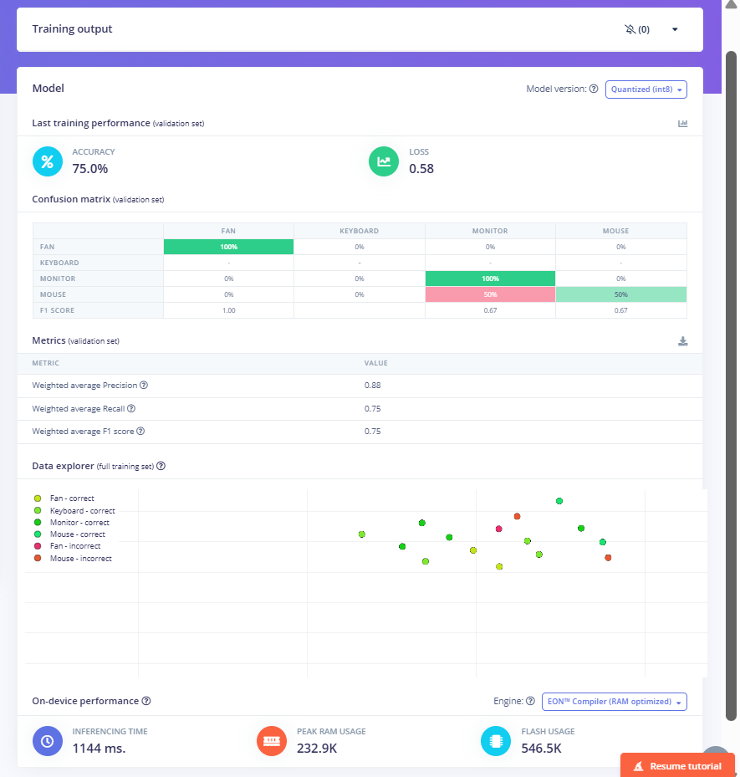

Classifier:
